**Government College for Girls Sector-14, Gurugram**

**NATIONAL SERVICE SCHEME**

**ANNUAL REPORT 2023-24**

* Celebration of Kargil Vijay Diwas Report – 2023 As per directive issued by the office of the Director of Higher Education, Panchkula via letter no. DHE-230008/9/2020-NSS-DHE(Misc.) Dated 17-07-2023. The Kargil Vijay Diwas celebration held at Government College for Girls, Sector-14, Gurugram The Celebration started on 26th July 2023 with Tree Plantation Drive in the college. Around 70 Saplings of Indigenous plants like Mango, Guvava, Neem , Lemon etc were planted by the Principal, Senior Faculty Member of the college, NSS Programme Officers, Students, Gardener, Sweeper etc. NSS Cell of the college also organised a Poster Making and an Awareness Rally under Plastic Free Campaign on 29th July 2023. Principal Madam motivated the NSS volunteers to create awareness among the students about the recycling of the plastic.

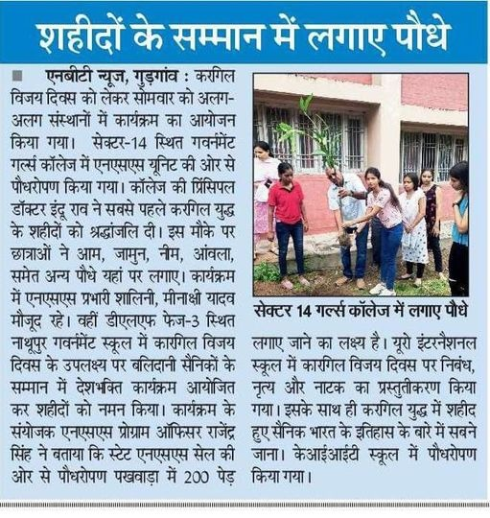 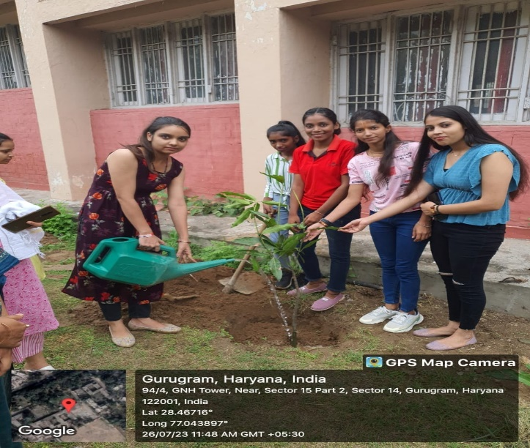

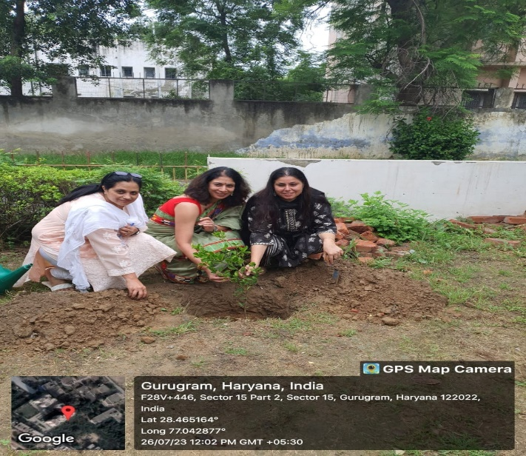 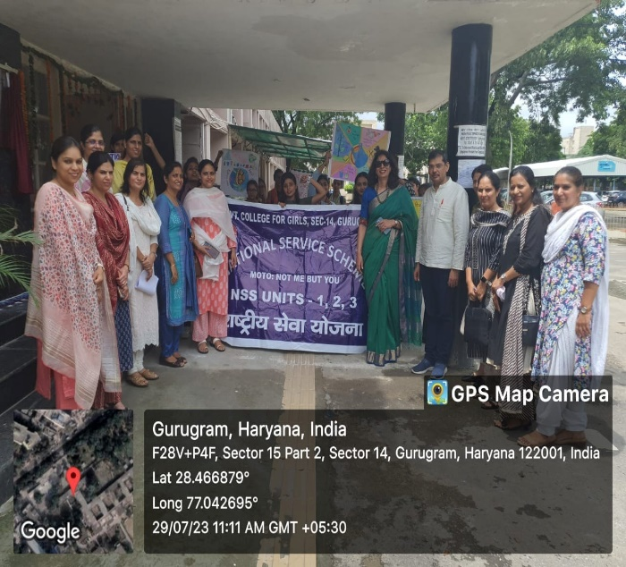

* **MERI MAATI MERA DESH CAMPAIGN (09th to 15th August, 2023)** -The NSS cell of Government College for Girls, Sector-14, Gurugram organized a series of impactful activities and celebrations in line with our commitment to community service, Patriotism, and environmental conservation.
  + On 11th August 2023 a meeting was organised by the NSS Programme officers Ms. Meenakshi Yadav, Ms. Shalini and Ms. Shweta Yadav with NSS volunteers. "MERI MAATI MERA DESH" campaign was discussed with the volunteers in detail by the programme officers.
  + NSS cell of the college started the above-mentioned campaign with "VEERON KA VANDAN" on 14 August 2023. Mr. Manoj Yadav, Sub-inspector CRPF, was the chief guest. The event was graced by the presence of our respected Principal Dr. Indu Rao. She honoured our chief guest with a memento and a planter as a token of our appreciation for his dedication and service to the nation.
  + In continuation, Mr. Manoj Yadav also administered the Panch Pran Pledge to NSS volunteers.
  + Under "VASUDHA VANDHAN" activity a green space named AMRI VATIKA was created in the college campus through the plantation of 75 indigenous plants on 14th August 2023. The event saw enthusiastic participation from NSS volunteers, faculty members, gardener also.
  + Continuing the patriotic spirit, on 15 August 2023 NSS cell of the college celebrated the 77th Independence Day. The day commenced with the hoisting of the National flag by the Vice-Principal Mrs. Savita Mahendroo. NSS volunteers also participated in Har Ghar Tiranga Campaign by uploading their selfie with Tiranga on the website. <http://harghartiranga.com>

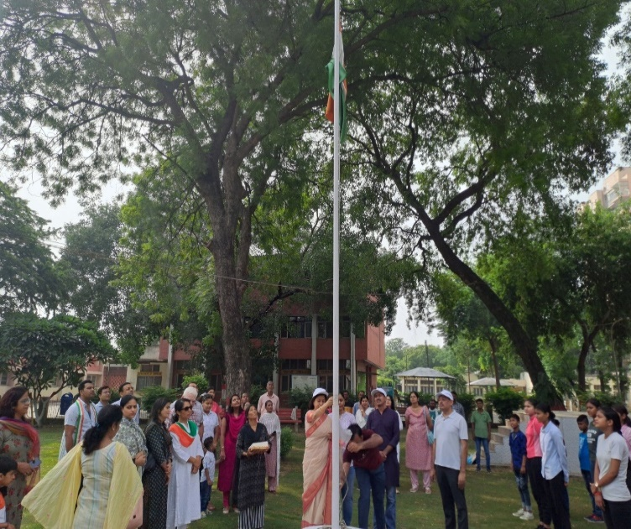 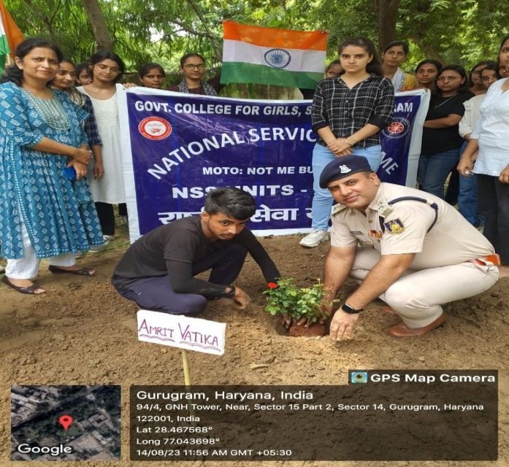

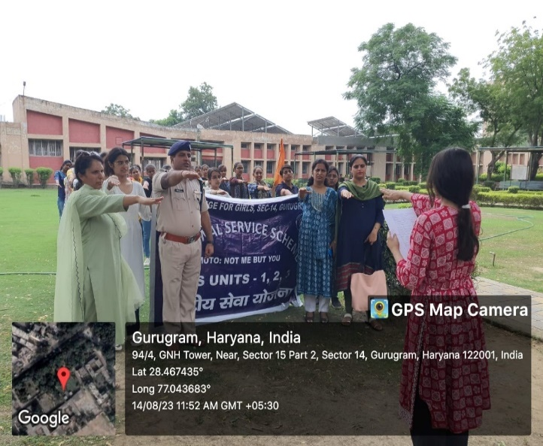 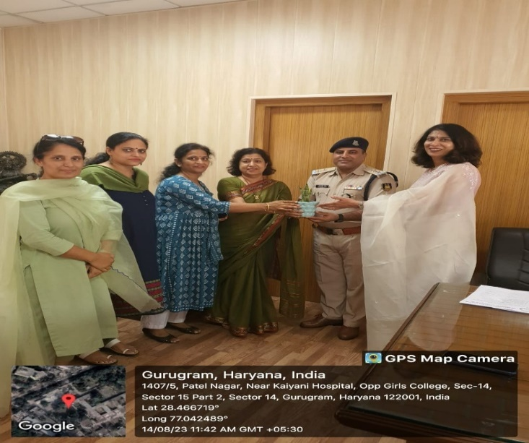

* NATIONAL SERVICE SCHEME of GOVT.COLLEGE FOR GIRLS SEC-14, GURUGRAM organized a POSTER MAKING COMPITITION ON THE THEMES- Nasha Mukti Abhiyaaan, Drug Abuse, Environment Protection, Plastic Free Haryana on 5th September 2023 in Reading Hall (College Library) at 9:30am. Selected Top three entries qualified for university level Competition. University Level Prize: Rs.2100/-, Rs. 1500/-and Rs.1100/- For 1st, 2nd &3 Position respectively.

At the university level poster making competition held on 6/09/2023 two students of our college Nidhi Sharma BA pass 1st year stood 2nd and Komal BSC NM 3rd year stood 3rd respectively.

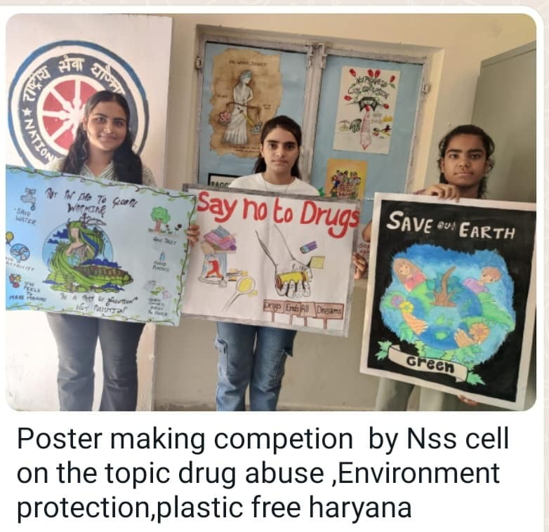 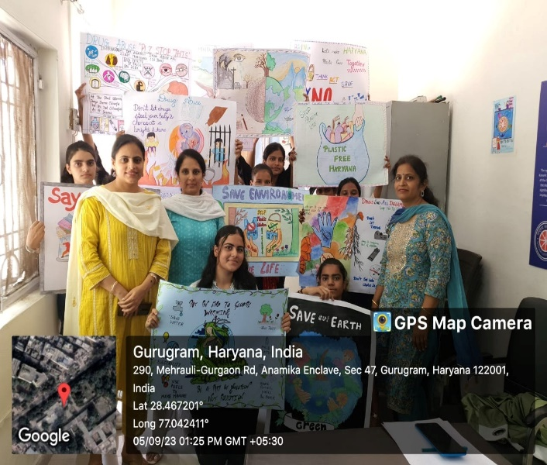

* **SWACHHTA HI SEWA CAMPAIGN** was organised from 15th September to 02th October, 2023.

The NSS cell of Government College for Girls, Sector-14, Gurugram organized a series of impactful activities in order to full fill our commitment to community service and Environmental Conservation.

**ACTIVITY-1** On 27°September 2023 SWACHHTA HI SEWA' campaign was discussed with the volunteers in detail by the programme officers. NSS volunteers assembled in the college campus and took Swachhta Pledge. 180 NSS volunteers participated in this

**ACTIVITY-2** On 29/09/23 NSS volunteers made there videos on cleanliness awareness which they shared on social media. 45 volunteers actively participated in this event

**ACTIVITY-3** On 01/02/23 a Cleanliness Awareness Rally was organised from college premises to Chandan Nagar basti. Cleanliness work was done by volunteers there. Volunteers told the residents about the side effect plastic and distributed cloth bags to people living there.

**ACTIVITY-4** On 02/02/23 NSS volunteers continued this awareness campaign in their local areas. 11 volunteers spread this cleanliness awareness went in their local area.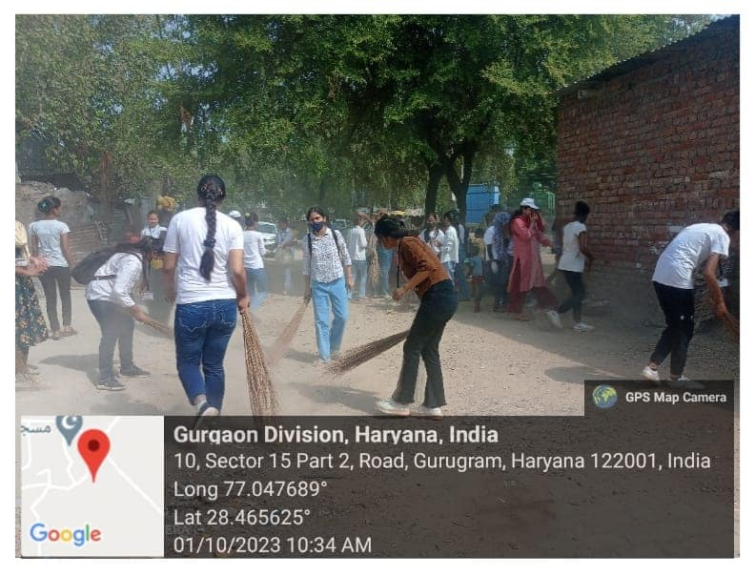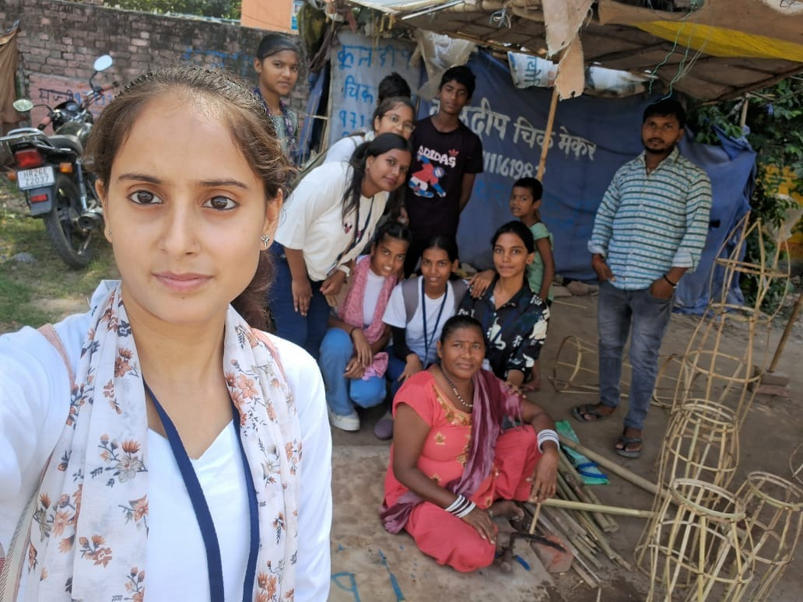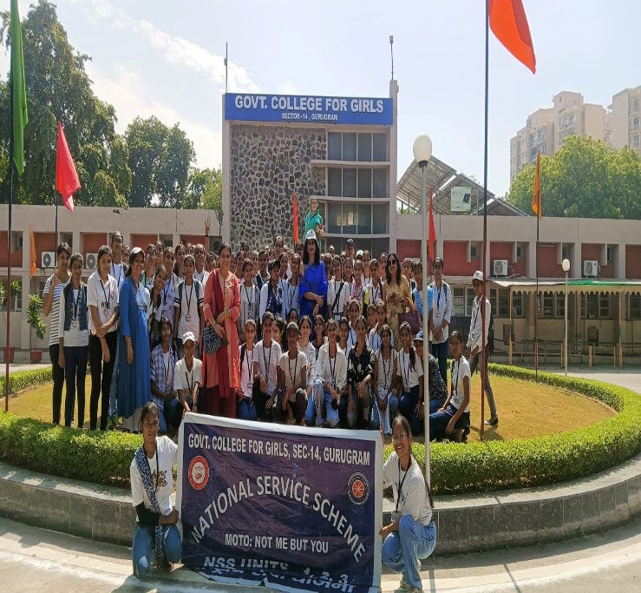 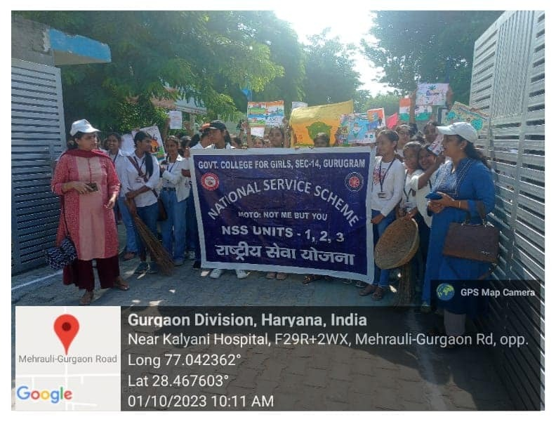

* **AMRIT KALASH YATRA and PANCH PRAN PLEDGE on 12 October 2023-**NSS Volunteers of all 3 units got mittis from their Village, town etc and collected in Kalash which was handed over to DC. Gurugram. Mitti was collected in Kalash and Volunteers took out an Amrit Kalash Yatra in College Campus with Patriotic slogans to create awareness among the students.

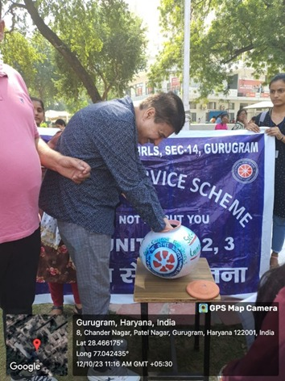 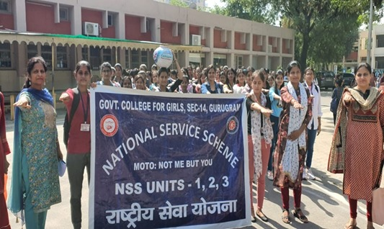

* The NSS cell of the college organised a lecture on the topic: Journey of khadi: Fabric: A freedom fabric to fashion Fabric" in Room No-43 on 27th October, 2023 at 11:00 AM -Mrs. Milli, Associate Professor, Department of Home Science, Govt. College for Girls was the resourse person for the same. Students learnt the importance of the fabric.

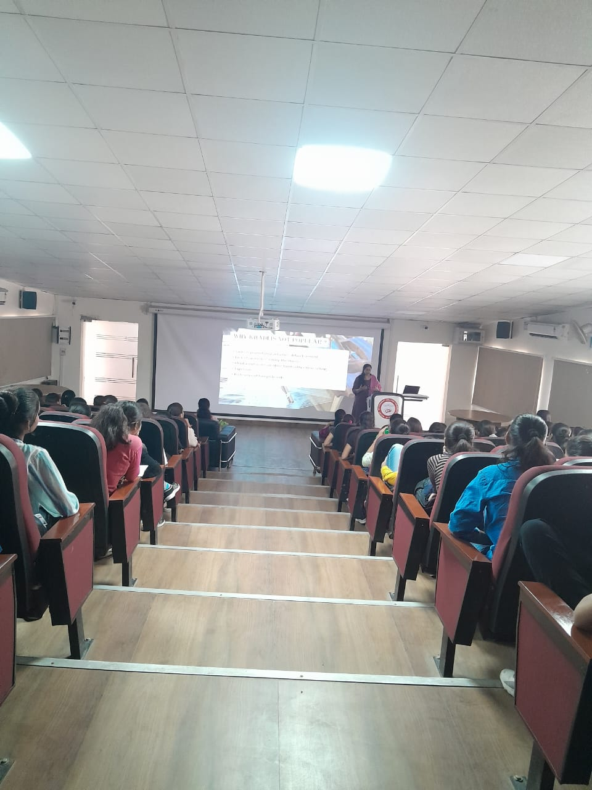

* The prestigious **27th National Youth Festival from January 12** to 16, 2024 was hosted by Nashik, Maharashtra. This event was inaugurated by Prime Minister Narendra Modi. Over 7,500 youths from different states and union territories participated in various events like cultural performances, indigenous sports, declamation and thematic-based presentations, young artist camp, poster making, story writing, etc. The theme for the festival was ‘Viksit Bharat@ 2047: For the Youth, By the Youth.’ Live screening of inaugural ceremony of was arranged in Seminar Hall. Approximately 120 volunteers attended the live screening.

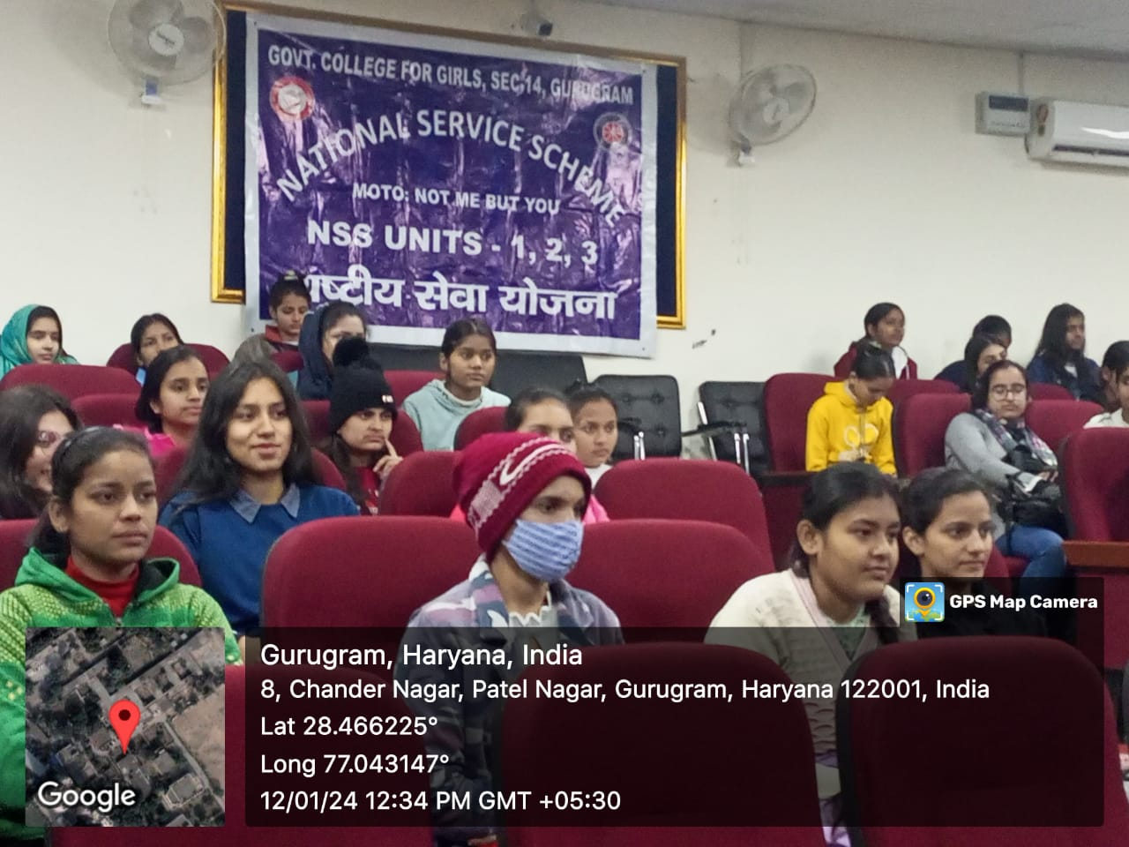 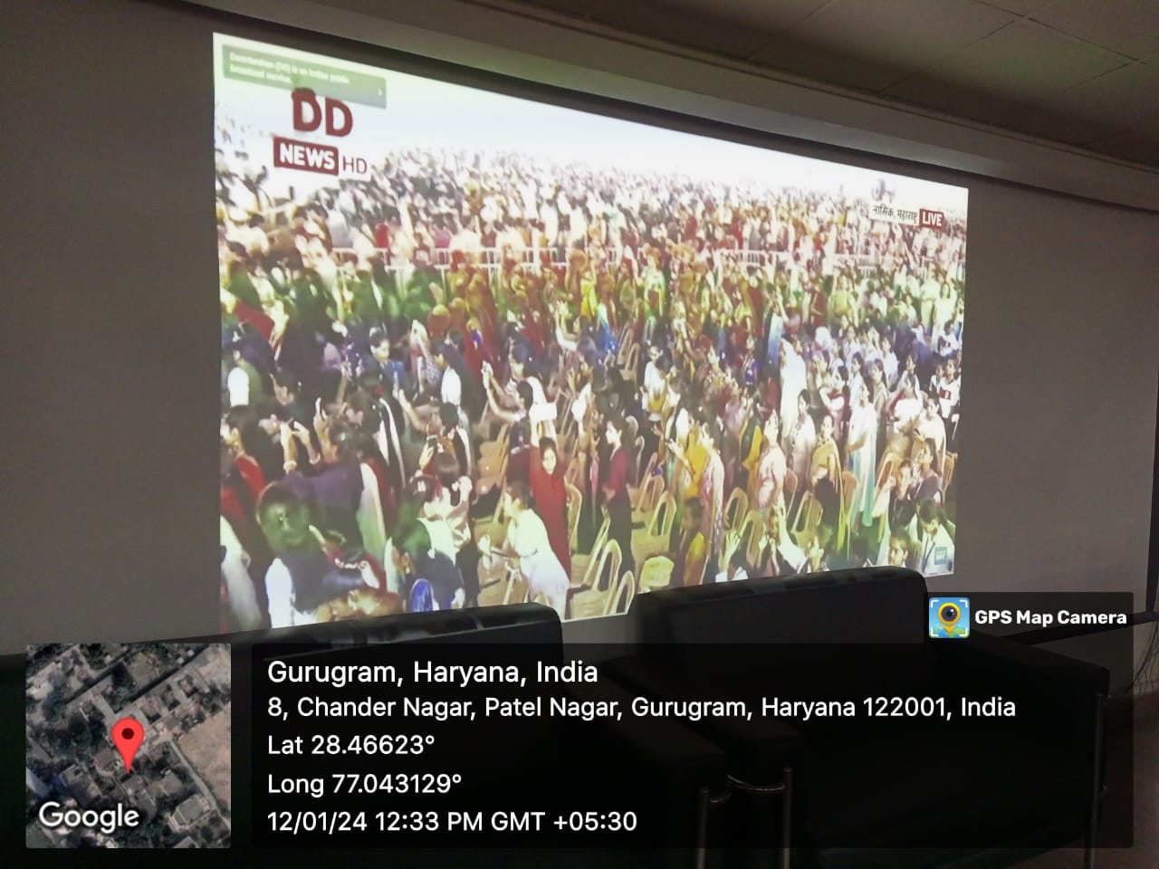

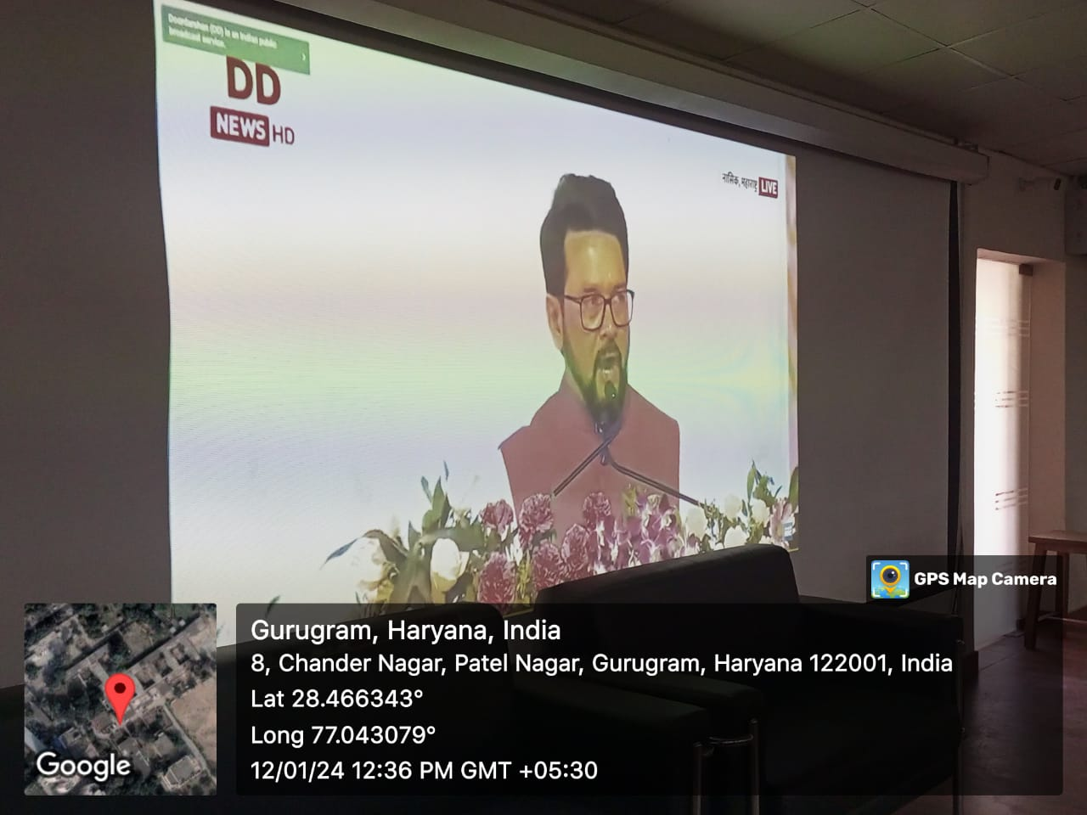 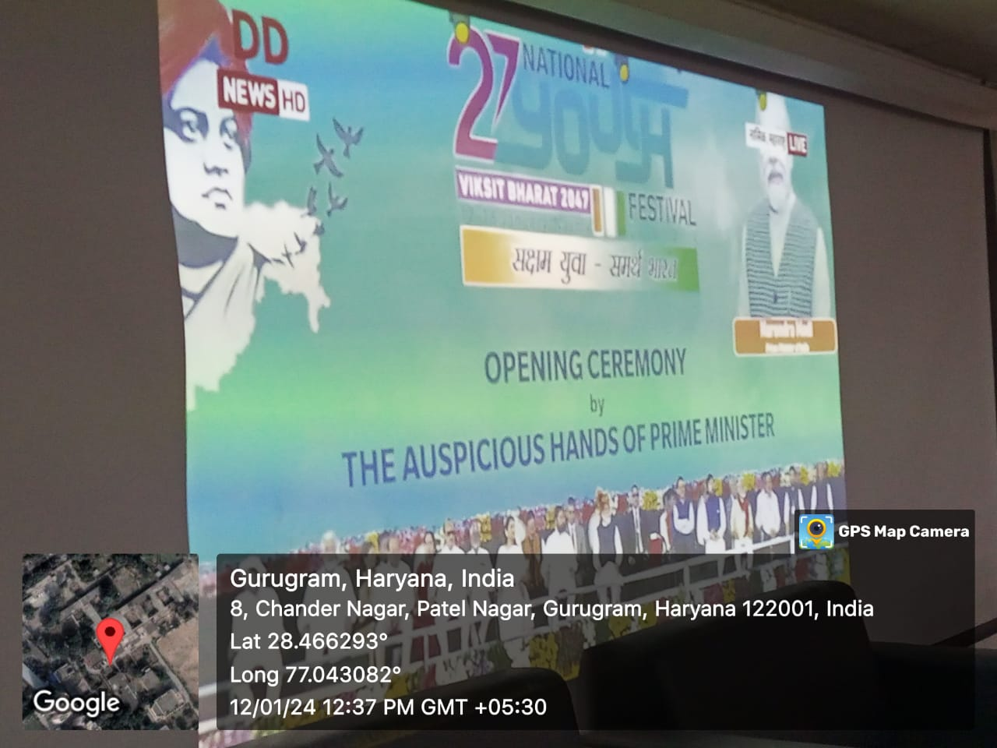

* 23rd January 2024, volunteers performed duties in organization of AISHE workshop
* 26th January 2024 volunteers celebrated Republic day by participating in flag hoisting. Volunteers sang NSS song and National Anthem.

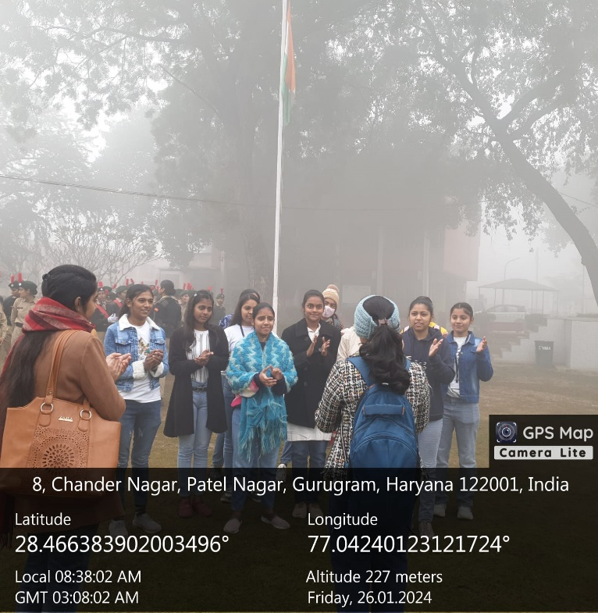 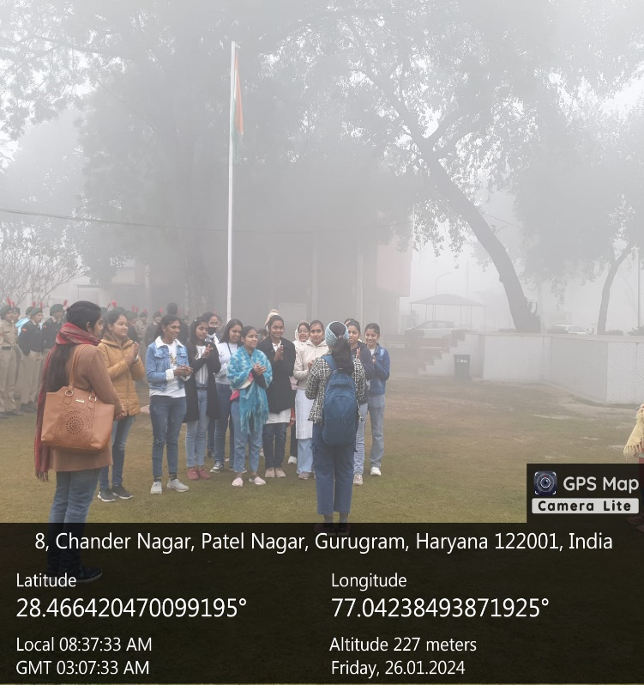

* 5th February 2024 volunteers participated in Saarthi event held at Gurugram University

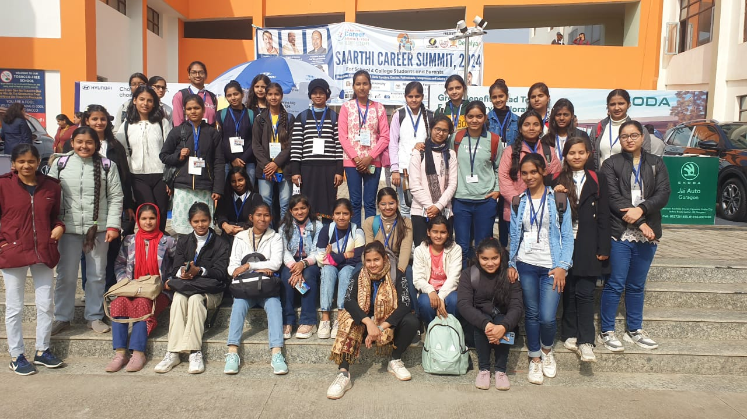

* 6th February 2024, one day camp was organized on the theme Road Safety Awareness. NSS volunteers participated in Poster making and Slogan Writing on the theme and organized rally on Road Safety Awareness. Continuing with the theme a special guest lecture by Ravi Kumar Sharma, Safety Manager, Hero MotoCorp Ltd. and Kaustubha Nand Joshi, Safety Manager, Hero MotoCorp was also held.

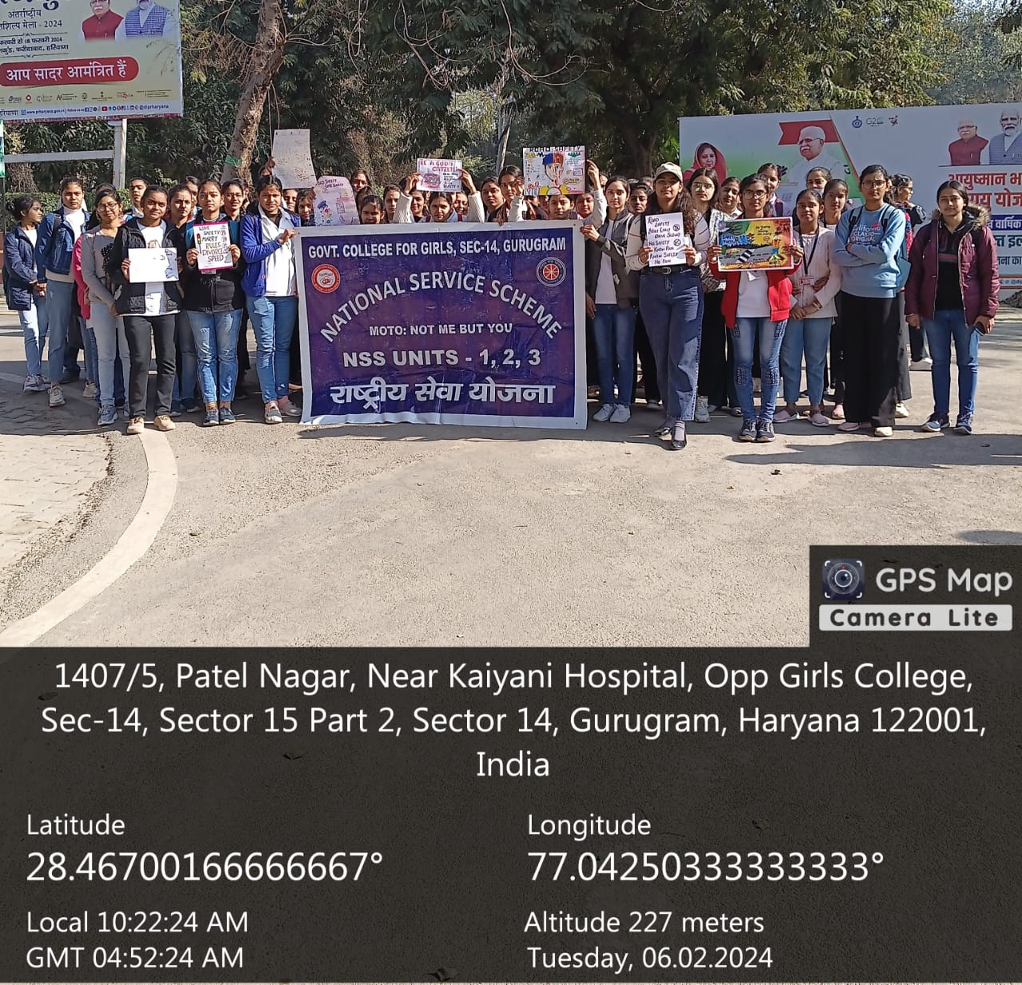

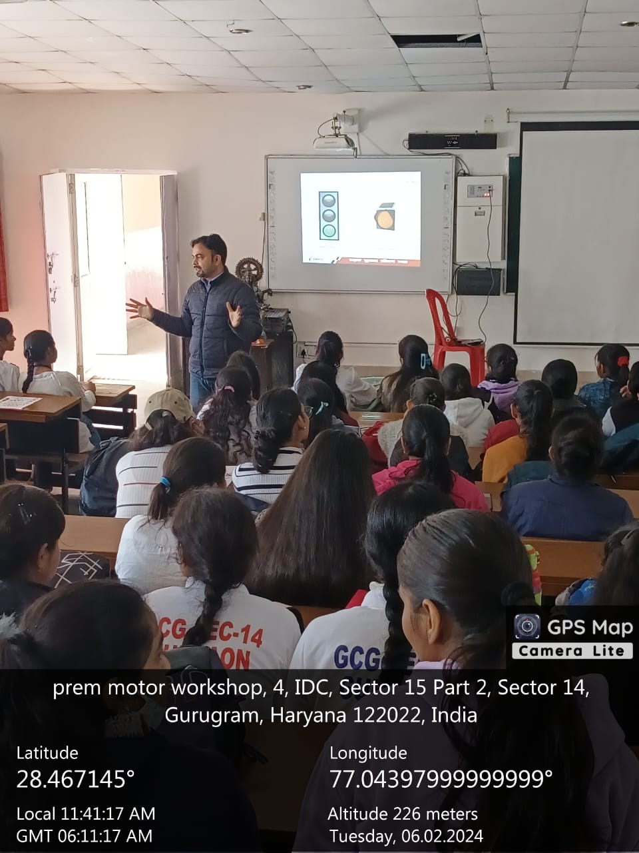 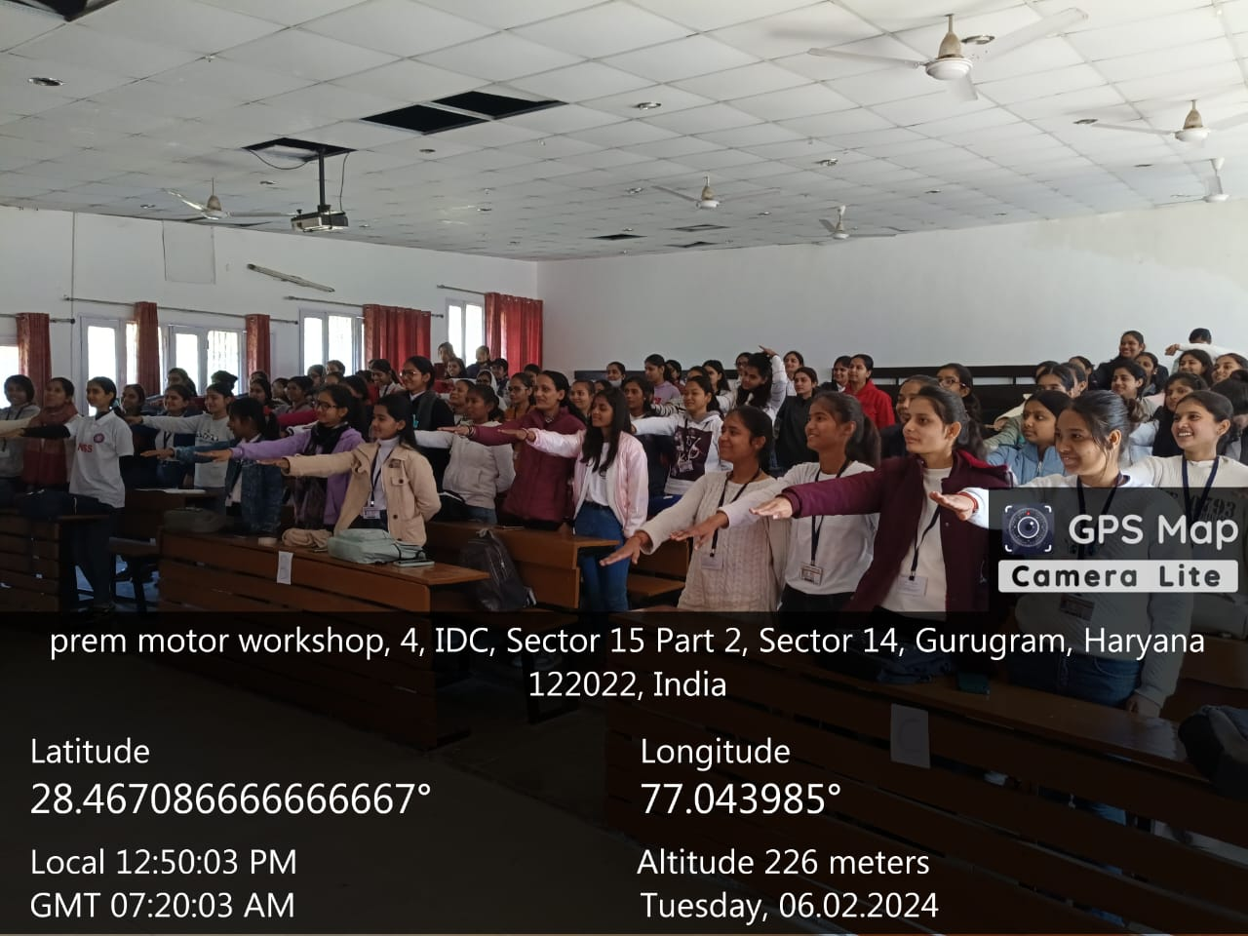

* 9th February 2024, volunteers performed various duties in arrangements during Zonal level Job Fair.
* 16-17th February 2024, volunteers performed various duties in arrangements and refreshment distribution during 60th Annual Sports Meet.
* **23rd-29th February 2024**, **Special Seven Day NSS Camp** was organized. Volunteers organized rally on Voter Awareness and Cleanliness. Various activities and guest lectures were held during camp. Mock polling, various competitions like poem writing, slogan writing, story writing, poster making, folk dance, folk song and reel making. Volunteers also performed Shramdaan and organized a donation drive.

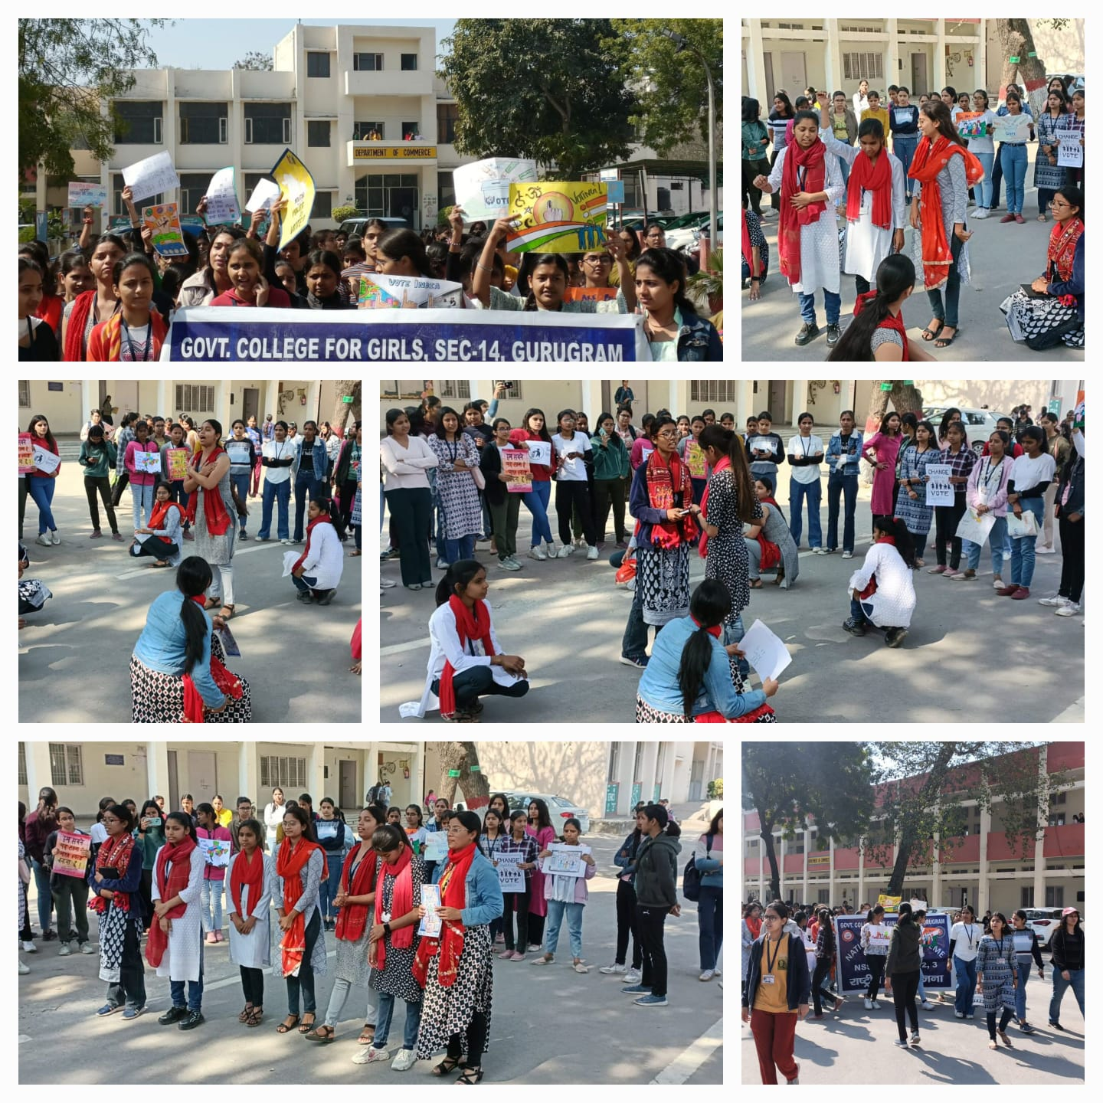

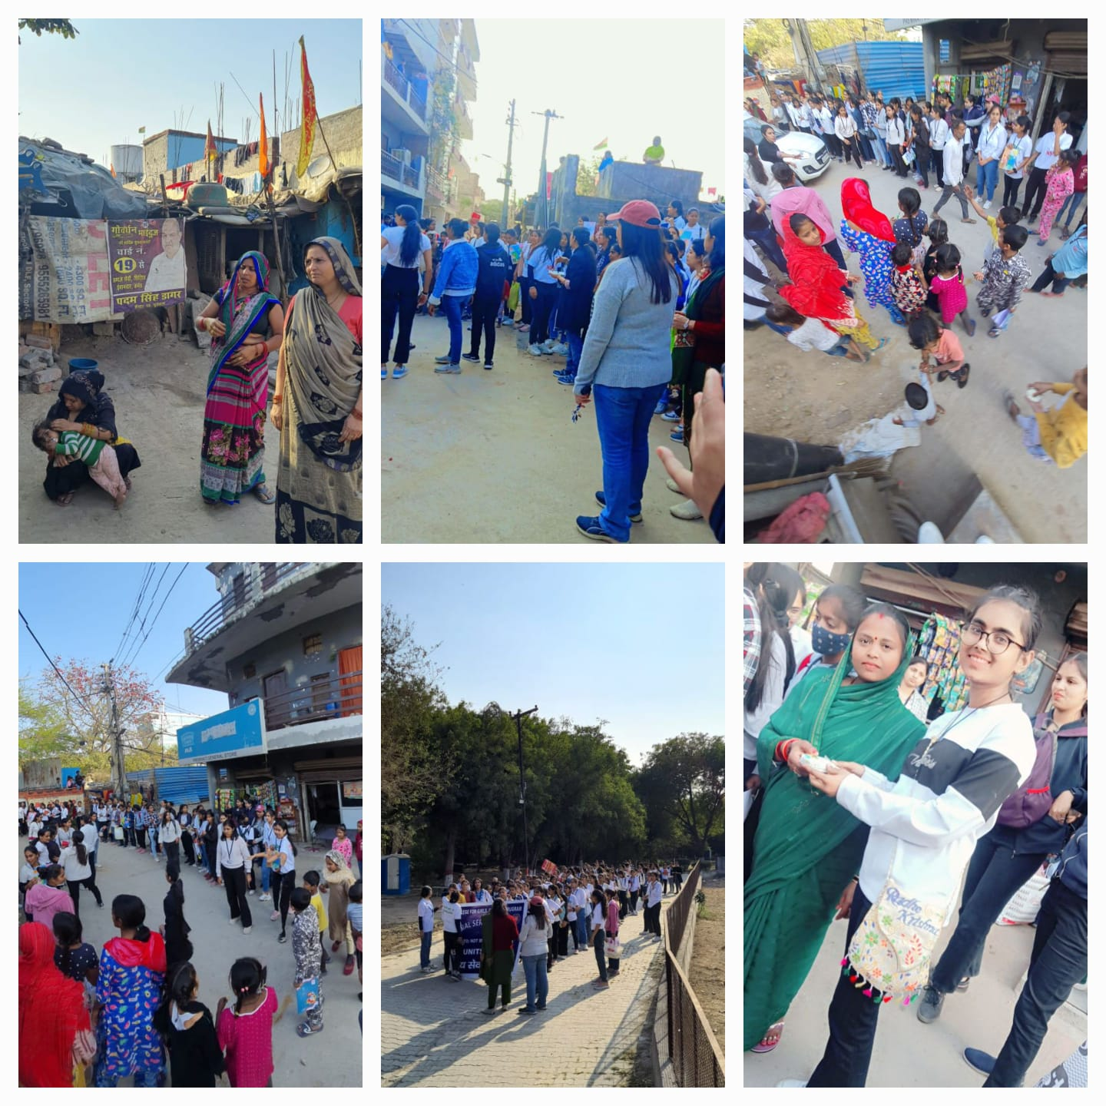

* 19th March 2024, one day camp was organized. Guest lecture by Ms. Ramita on “Social Welfare with no single use plastic”. Another guest lecture Dr. Rajesh Beniwal on topic “Social Media and Cyber Crime”. Shramdaan was done by volunteers.

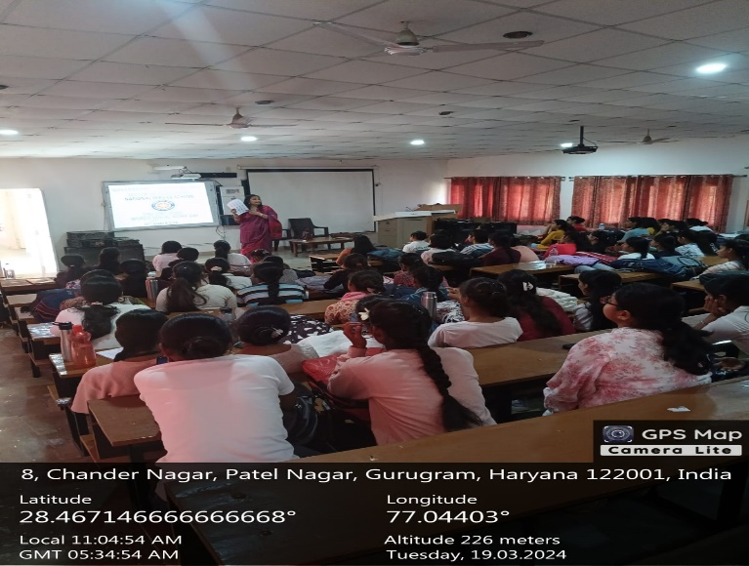 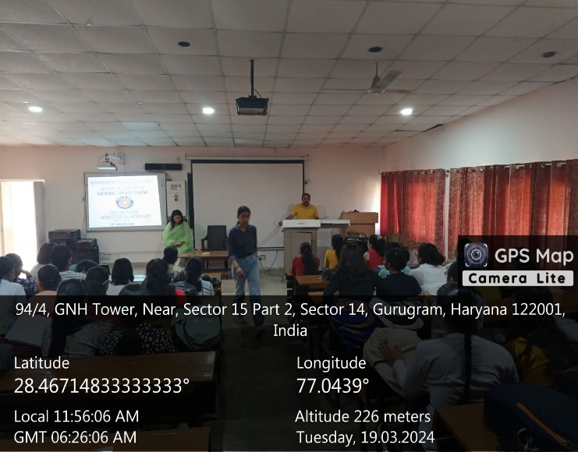

* 20th March 2024, one day camp was organized. A workshop was organized on by Ms. Ridhi from Art of Living. A short animated film on Happiness was screened and various fun activities were performed by volunteers. Shramdaan was done by volunteers.

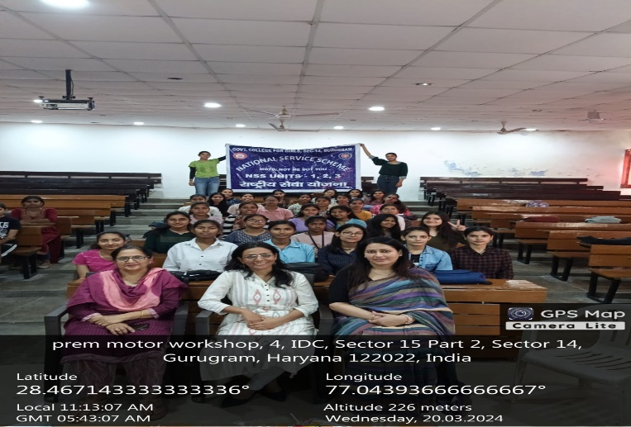 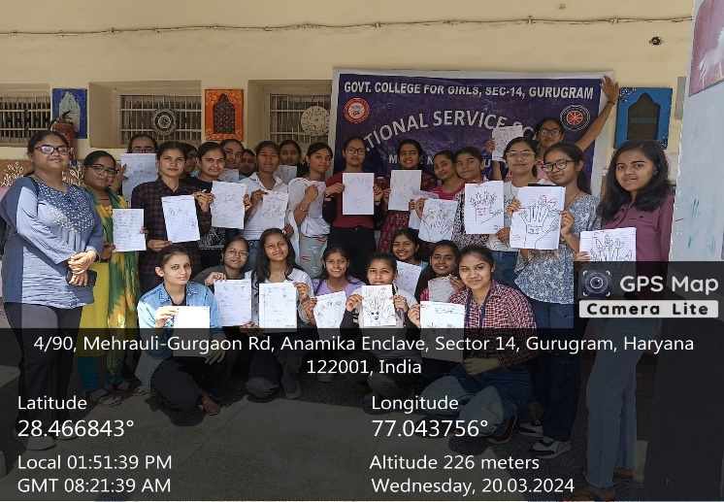

* A Voter Awareness campaign was carried out in the college on 12th April 2024. As part of the campaign renowned Haryanvi singer MD Desi Rockstar (k Manoj Kumar), who is the brand ambassador of the Systematic Voters’ Education and Electoral Participation (SVEEP) program in Gurugram District, visited the college and interacted with the NSS and NCC volunteers.

