**GOVERNMENT COLLEGE FOR GIRLS SEC-14, GURUGRAM**

**Affilated to**

**GURUGRAM UNIVERSITY, GURUGRAM**



**Disabled-friendly, barrier free environment in the institution**

**Built environment with ramps/lifts for easy access to classrooms.**

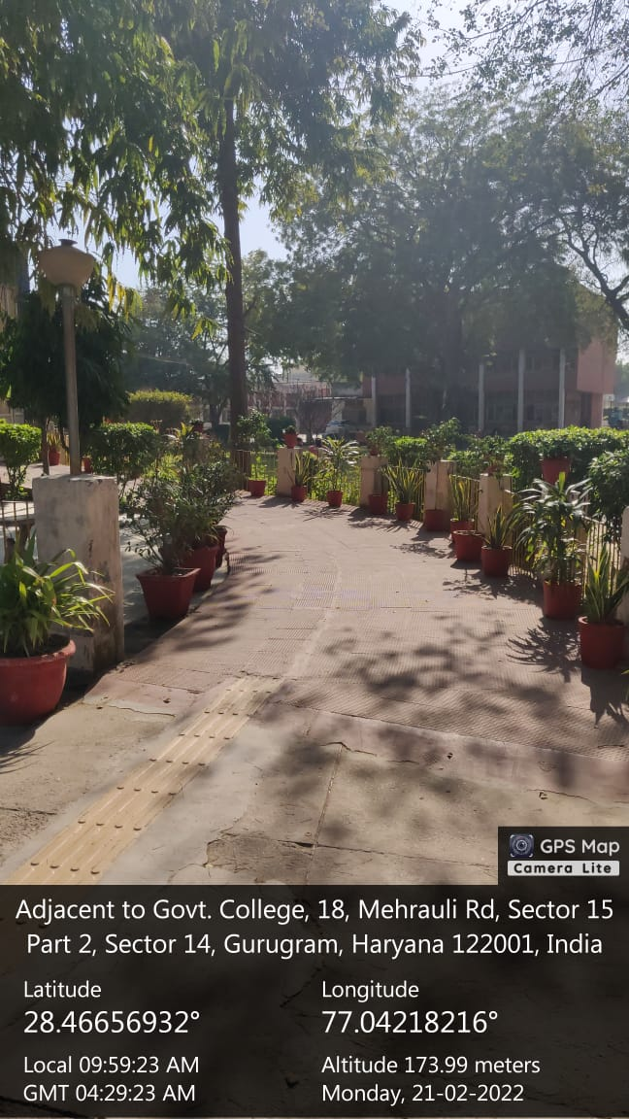

**Signage including tactile path, lights, display boards and signposts**

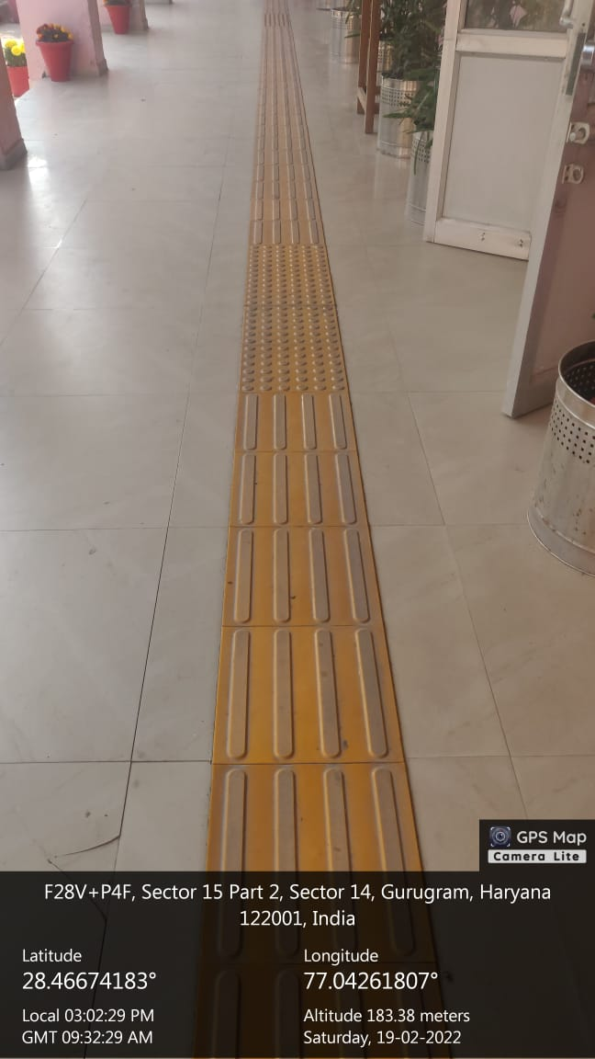

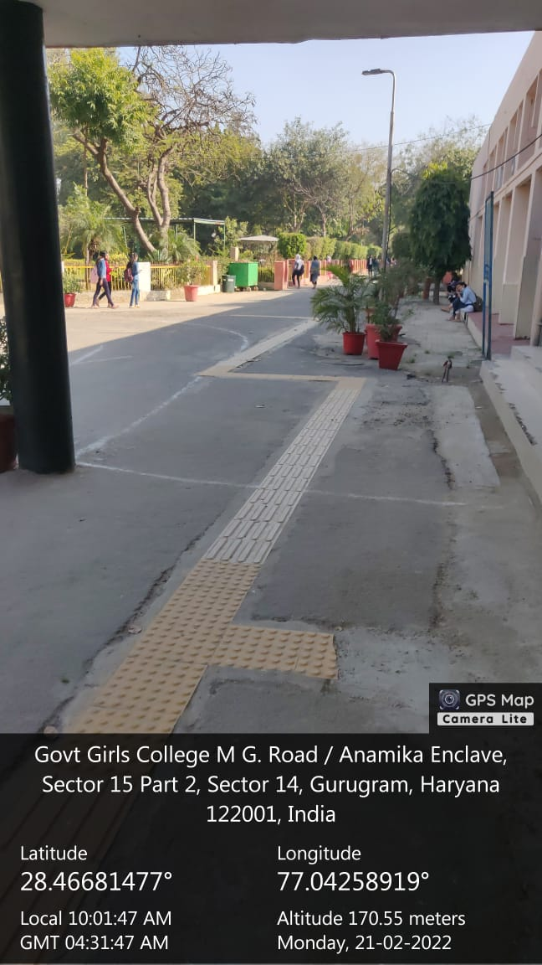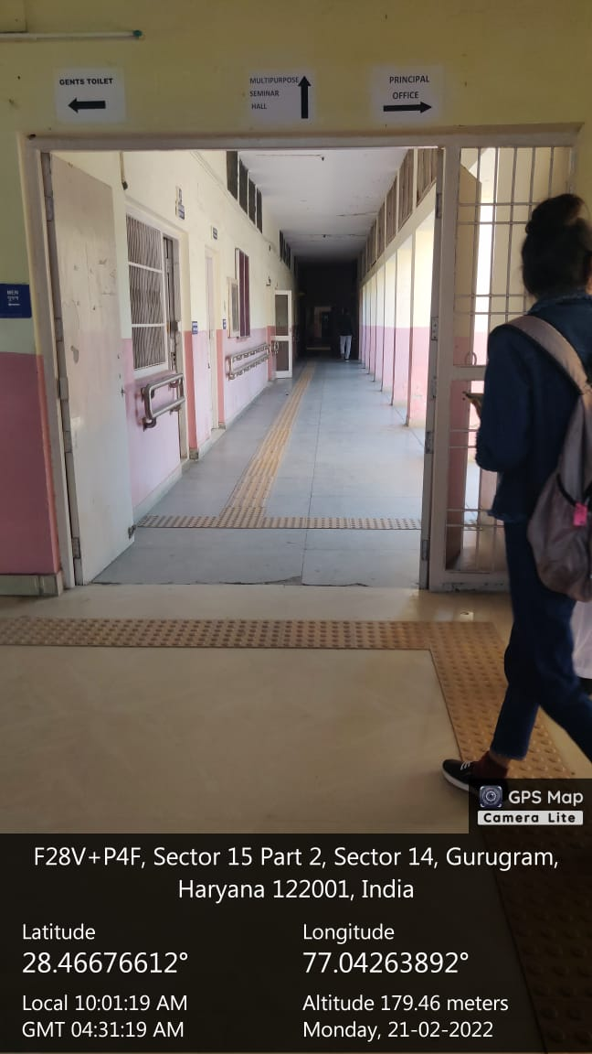

**Disabled-friendly washroom**

**Provision for enquiry and information: Human assistance, reader, scribe, soft copies of reading material, screen reading**

**Braille Book**

**Braille Magazine for Blind in the college**

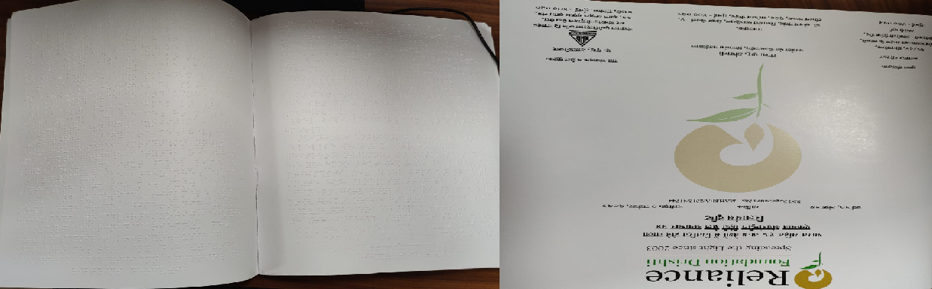

**Scibes**

Provision for request for a scribe is available in college. The application for the scribe is to be submitted to the Principal along with required documents.